Education
software
Toonboom Harmony
Storyboard Pro
Adobe Animate
Adobe Photoshop
Adobe After Effects
Syncsketch

Technical
skills
Traditional Animation
Rigged Animation
2D Cleanup & Color
Storyboarding
FX Animation

Bachelor of Fine Arts in 2D Animation 2021
Savannah College of Art and Design, Savannah GA
Master of Fine Arts in Sequential Art 2024
Savannah College of Art and Design, Savannah GA
Collaborative experience
Wander 2021
2D Character Animation • Cleanup & Color • Storyboarding
➥ responsible for 36 seconds of rough animation.
➥ Created initial storyboards for two scenes.
➥ collaborating with team members whilst working remotely.
➥ providing deliverables in a timely fashion, adjusting work according to feedback.
➥ balancing multiple shots simultaneously.
Adobe Animate Collaboration 2020
2D Character Animator
➥ Responsible for animation of single panel.
➥ Coordinated with a variety of animators in order to unify panels.
➥ Coordinated with Adobe devs to learn and troubleshoot features of Animate.
Mr. Hamboni 2020
Producer • 2D Character Animator • Layout Artist
➥ Management of a team to ensure project deadlines are met
➥ responsible for 6 seconds of character animation
Dung Love 2020
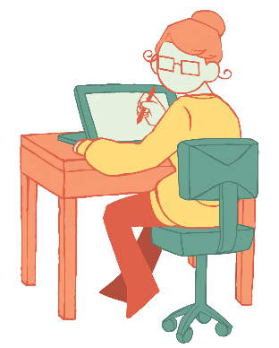
2D Cleanup • Color Artist
➥ Produced on-model cleanup based on finished rough animation.
Summer Catch 2020
Producer • 2D Character Animator • storyboarding • Layout Artist

Achievements
Adobe Animate Collaboration
➥ Collaboration project featured on the Adobe Blog

